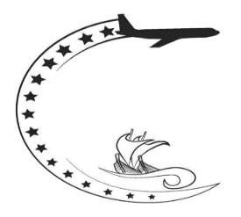
JOB DESCRIPTION
Airport Authority Cook Islands

JOB TITLE:  B  TITLE: | AIRPORT SECURITY OFFICER (ASO)
WORK UNIT: | AIRPORT SECURITY SERVICE
SALARY BAND: B SIZE: 151-200 GRADE: 2 STEP: 4 - 13 ($17,909 - $23,397)
RESPONSIBLE TO: | TEAM LEADER / SHIFT LEADER
JOB PURPOSE: | To implement standards which ensure the safety and security of Rarotonga International Airport
VISION STATEMENT: | Secure Grounds, Safer Skies
DATE REVIEWED: | January, 2020 : Chief Airport Security Officer
ORGANISATION CONTEXT:
AACI ORG STRUCTURE | AIRPORT SECURITY SERVICE ORG STRUCTURE
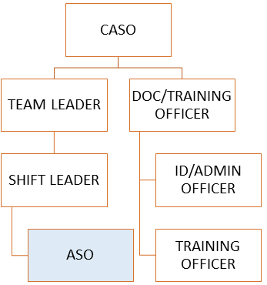
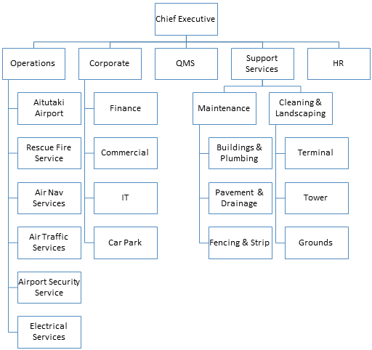
FUNCTIONAL RELATIONSHIPS:
EXTERNAL CONTACTS | NATURE OF CONTACT
General Public | Courtesy, giving and receiving information, explaining things to people, clarifying needs
Airlines and airport community | Giving and receiving information, explaining things, liaising, advising, gaining cooperation, facilitating, persuading, resolving conflicts, negotiating.
Government Agencies | Giving and receiving information, explaining things, liaising, advising, gaining cooperation, facilitating, persuading, resolving conflicts, negotiating.
Passengers | Giving and receiving information, explaining things, liaising, advising, gaining cooperation, facilitating, persuading, resolving conflicts, negotiating.
CAA, TSA, OTS, PASO (external audits) | Giving and receiving information, explaining things, liaising, advising, gaining cooperation, facilitating, persuading, resolving conflicts, negotiating.
Concessionaires | Giving and receiving information, explaining things, liaising, advising, gaining cooperation, facilitating, persuading, resolving conflicts, negotiating.
INTERNAL CONTACTS | NATURE OF CONTACT
AACI Management and Staff | Giving and receiving information, explaining things, liaising, advising, gaining cooperation, facilitating, persuading, resolving conflicts, negotiating.
Airport Security Service Staff | Giving and receiving information, explaining things, liaising, advising, gaining cooperation, facilitating, persuading, resolving conflicts, negotiating.

AUTHORITY:
Financial | NO
Staff | NO
Contractual | NO

KEY RESULT AREAS:
JOB HOLDER IS ACCOUNTABLE FOR | JOB HOLDER IS SUCCESFUL WHEN
- ACCESS CONTROL
Having a working knowledge of access control standard operating procedures and measures | - Able to demonstrate knowledge and application of access control measures and procedures by successfully completing annual competency assessments
Monitoring and controlling the access of persons, items, substances, vehicles into the airside or security areas of the airport | - Only authorised persons, items, substances and vehicles are in the airside at all times  - All airport users and vehicles are displaying valid airport ID cards and airside permits in designated areas within the airside – at all times.
Conducting mobile and foot patrols and aerodrome perimeter inspections ensuring that facilities and all areas giving access to the airside – are secure and structurally sound | - Integrity of security perimeter fences, grilles and buildings – is maintained.  - Scheduled inspections are conducted and results recorded accordingly
Ensuring that all areas giving access to the airside or security areas are secured when not in use | - All areas giving access to airside or security areas are secure at all times and there are no instances of unauthorised entry via these access points.
- SAFETY & SECURITY INSPECTIONS AND SCREENING
Demonstrating knowledge and application of access control, screening and search measures and procedures | - Completes and passes all recurrent tests  - No prohibited items and dangerous goods pass the screening checkpoint  - Successfully completes training and development plans for each fiscal year
Carrying out searches and screening of persons, items, substances, buildings, vehicles and aircraft entering or within the airside or security areas of the airport | - Continuously attains established X-ray Tutor CBS and HBS standards  - No prohibited or hazardous items and substances are taken into the sterile holding area, security area, cargo area or on board an aircraft  - There are no reports or complaints of breaches to security or safety requirements  - Audit and inspection results are successful
Performing aerodrome runway and lighting inspections when required by Air Traffic Control | - Runway is free of debris, FOD and wildlife  - Pavement, lighting and visual aid deficiencies are identified and reported to ATS
- VEHICLE AND EQUIPMENT OPERATIONS AND CARE
Operating and taking care of company vehicles, security equipment and tools accordingly  Performing routine checks of security equipment and tools to ensure on-going operational effectiveness | - Demonstrates knowledge of the operation of all security and communications equipment  - Demonstrates knowledge in conducting pre-operational checks of security and communications equipment relevant to the screening checkpoint  - Equipment, vehicles and tools are free from damage or misuse  - Checks, faults and deficiencies are recorded, reported and followed up
- ADMINISTRATION AND REPORTING DUTIES
Maintaining technical and operational knowledge | - All scheduled training sessions are attended  - Policy, legal and procedural documents are read at least once a year
Ensuring that all instances of safety and security breaches are recorded and reported immediately – in accordance with procedures | - Demonstrates ability to generate OFD reports and furnished as soon as practicable  - Submits incident reports for security incidents within 3 working days
- INCIDENT AND EMERGENCY SUPPORT
- Responding to aircraft, security and safety incidents and emergencies  - Rendering assistance in coordinating security response procedures for aerodrome and security emergencies | - Demonstrates knowledge in the application of emergency procedures for all known scenarios
- WELLNESS AND FITNESS
Maintaining wellness and fitness standards established for the section | - Participates in scheduled wellness and fitness activities  - Successfully completes wellness and fitness programmes
- MISCELLANEOUS
Undertaking such other duties and responsibilities as directed by the Chief Airport Security Officer. | Successfully carries out instructions with positive results achieved
NOTE: The above performance standards are provided as a guide only. The precise performance measures for this position will further discussion between the job-holder and manager as part of the performance development process.

WORK COMPLEXITY:
Most challenging duties typically undertaken:
- Applying Challenge Procedures when faced with unauthorised, unscreened and unruly persons within the airside or security areas or on board aircraft
- Processing OFD Reports and producing timely incident reports
- Diverse safety and security duties performed
- Communicating with different airport agencies and the travelling public
- Recalling regulatory and legal requirements and their application in the conduct of security and safety duties.
- Responding to various aircraft, security and safety emergencies
PERSON SPECIFICATION:
QUALIFICATIONS
ESSENTIAL | DESIRABLE
Must have a minimum of NCEA Level 1 (10 CREDITS each for English and Mathematics); or Cook Islands School Certificate (CISC) with passes in English and Mathematics (or equivalent); | - NCEA Level 2 or 3 with required credits achieved for English and Mathematics; or  - Aviation Security Certificate or equivalent;
KNOWLEDGE/EXPERIENCE/SKILLS
ESSENTIAL | DESIRABLE
- Basic computer literacy skills in MS Word and Excel  - Basic reading and numeracy skills  - Able to drive manual and automatic transmission motor vehicles (note: equal to Class-B)  - Ability to work in a team environment  - Good people skills including customer relations and communications skills  - Able to demonstrate a level of maturity as expected of those who have been in the workplace for 1 – 2 years or more  - Undergo and pass an initial and subsequent scheduled medical examinations; and  - Undergo and pass an initial and subsequent scheduled background (criminal and employment history) checks | - Has workplace experience with at least 2 years in the field of security or similar  - A good grasp of the Cook Islands Maori and other languages  - Previous experience in military or law enforcement related jobs

KEY SKILLS/ATTRIBUTES/JOB SPECIFIC COMPETENCIES
The following levels would typically be expected for the 100% fully effective level:
WORKING KNOWLEDGE | Competent in applying standards and procedures. Ability to interpret, analyse and comply with security and safety information and directives
AWARENESS | Full awareness, understanding and working knowledge of responsibilities of the Airport Security Service
KEY BEHAVIOURS
All employees are measured against the following Key Behaviours as part of Performance Development:
- Behave in ways which provide customers with a positive experience when using the airport or services
- Demonstrates effective communication
- Promotes environmental and social responsibility
- Demonstrates effective teamwork
PERSONAL ATTRIBUTES:
- Physically fit and strong
- The ability to lead and motivate a team and a clear communicator
- Resilience
- Ability to think on and off your feet
- Ability to sum up the situation and make decisions quickly if required
CHANGE TO JOB DESCRIPTION
From time to time, it may be necessary to consider changes in the job description in response to the changing nature of our work environment – including technological requirements or statutory changes. Such change may be initiated as necessary by the manager of this position. This job description may be reviewed as part of the preparation for performance planning for the annual performance cycle.
APPROVED
 |  | 21-July-2021
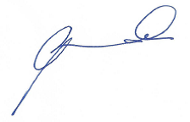  JOSEPH NGAMATA  CHIEF EXECUTIVE |  | DATE

